CASTLE HILL PLAYERS
ANNUAL GENERAL MEETING
Notice to Members

The next Annual General Meeting of the Castle Hill Players will be held on Tuesday, 16th April, 2013 at the Pavilion Theatre commencing at 8.00 p.m.

Members wishing to submit motions and/or items of special business at this meeting should forward them to the Secretary, Jewell Johnson.

All motions and/or items of special business must be in writing and must be received by the Secretary by 5.00 p.m., Friday, 15th March 2013. Motions must include the name of the mover and the seconder. Only financial members of the association are eligible to propose and second motions.

Motions should be forwarded by mail to:
Jewell Johnson 19 Lachlan Court Kellyville Ridge, NSW 2155

Or submitted by email to: songearts@mac.com

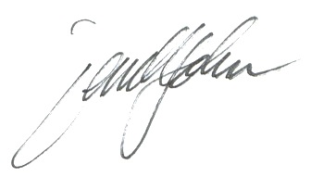
Jewell Johnson
SECRETARY – CASTLE HILL PLAYERS.

